Scalable Content-Aware Collaborative Filtering for Location Recommendation

Abstract:
Location recommendation plays an essential role in helping people to find attractive places. Newly developing cities, the growing number of locations of interest, restaurant, attractions(shopping mall, movie, park etc) people get more opportunity for entertainment, people entertain with neighborhoods and visiting locations comes to their interest, location recommendation has been exploited to help people discover interesting places and speed up users familiarization with their surroundings and new people, users often leave comments about venues on geographical location-based social networks after visiting location creating business opportunities for the user through mobile and email advertising.

how to recommend locations with social and geographical information, few of them addressed the cold-start problem of new users. Because mobility records are often shared on social networks, semantic information can be leveraged to tackle this challenge. A typical method is to feed them into explicit-feedback-based content-aware collaborative filtering. We then develop an efficient optimization algorithm, scaling linearly with data size and feature size, and quadratically with the dimension of latent space.

Existing System:

Observe and collect the details of users offenly visits amuzement places, restaurant places track the data mostly like. Users often leave comments and likes about venues on location-based social networks after visiting location recommendation has been exploited to help people discover interesting places and speed up users familiarization with their surroundings. Creating business opportunities in that area and advertise through mobile and email for the users.

Male users prefer to show visits to offices, residences, hotels, and educational institutions while female users are more likely to visit shops, entertainment venues, and restaurants. Therefore, males and females have different preference when visiting locations. Based on the relationship between age and visited locations, we find that young users (around 18-26 years) prefer to visit campus-related locations like teaching buildings and universities. This is because most of these users are students, living in and around campus. It is more likely for users older than 26 years to visit restaurants and entertainment venues, since such a visit is more interesting to share with friends. However, the preferences of older users are much weaker than for younger ones. Finally, we measure the relationship between user tweets and locations by their dot product in the latent space and choose the top 100 correlated keywords. We then observe that most words associated with locations are geographical. Taking the locations of attractions and outdoors as an example, they can be correlated with “railway stations”, “services zone”, “shopping malls”, and so on. Therefore, such a correlation may be not only explicit but also implicit, indicating their effectiveness in promoting recommending performance and dealing with cold-start cases.

Proposed System :

Improving to recommend and add more new places and to collect feedback comments, ratings for the entertain place user has visited. improving business opportunities through mobile and email advertising for the users.

Propose an efficient coordinate descent optimization algorithm to learn parameters in the sparse and rank-one weighting schemes, which scales linearly with data size and feature size, and quadratically with the dimension of latent space. In addition to theoretical analysis of time complexity, we empirically study convergence and efficiency issues in the proposed optimization algorithm.

Propose a scalable Implicit-feedback-based Content-aware Collaborative Filtering (ICCF) framework to incorporate semantic content and to steer clear of negative sampling. We then develop an efficient optimization algorithm, scaling linearly with data size and feature size, and quadratically with the dimension of latent space. We further establish its relationship with graph Laplacian regularized matrix factorization. Finally, we evaluate ICCF with a large-scale LBSN dataset in which users have profiles and textual content. The results show that ICCF outperforms several competing baselines, and that user information is not only effective for improving recommendations but also coping with cold-start scenarios.

Modules:

1.Location recommendation

Location has been an important topic in location-based services. From the perspective of types of recommended items, some prior research focuses on recommending specific types of locations while others are
generalized for any type of locations, have developed a user-based collaborative filtering system to recommend shopping mall, amusement places, and restaurants to a user. Jointly exploit geographical influence and collaborative filtering for recommending points of interest (of any category) given large scale mobility records from location-based social networks. Following this, more sophisticated models, such as jointly modeling geographical and social influence, and performing model-based collaborative filtering such as matrix factorization, tensor factorization, and word embedding techniques, have been proposed with the aim of seamless integration. Specifically, recommending locations for new users. A general solution is to integrate collaborative filtering with content-based

2. Business Opportunity

Add business opportunities and Advertise through email and mobile to users. With the support of massive data, location recommendation. leverage spatial patterns, temporal effects, spatio-temporal influence, social influence, text-based analysis, and implicit characteristics of human mobility, to recommend locations. Some of these methods require each user to have sufficient training data while others assume locations have accumulated ample textual information, making it challenging to use them to tackle.

3. Prediction and Loss function

ICCF (IMPLICIT FEEDBACK BASED CONTENT-AWARE COLLABORATIVE FILTERING) takes a user-location preference matrix, a user-feature matrix, and a location-feature matrix as inputs. Based on these, ICCF first generates the weighting matrix and the preference matrix. Feature to define the prediction preference of a user u for a location as when not considering biases, where each row of latent matrices. represents latent factors of user features and location features. Consequently, not only users and locations, but also their features are mapped into a joint latent space, where the inner product between them indicates one’s preference for another. For example, the dot product p between the latent factor of a user u and the latent factor of a location’s feature “restaurant” indicates the prediction preference of the user u for restaurants.

4. ICCF Evaluation
ICCF is evaluate on a large-scale location-based social network and collects data from social websites, a location based social network. Select POIs that are visited by at least ten users and users who have been to at least ten distinct locations. Users are linked to social network, we are able to collect rich semantic content, such as tweets and tags, and profile information, including age and gender, from users. This information can be used to improve recommendations, Collects each user’s tags and tweets. Evaluate recommendation on visited locations in the held-out set. Presenting each user with the top p candidate locations sorted by their preference prediction, we assess recommendation performance by checking how many of these locations actually appear.

Architecture

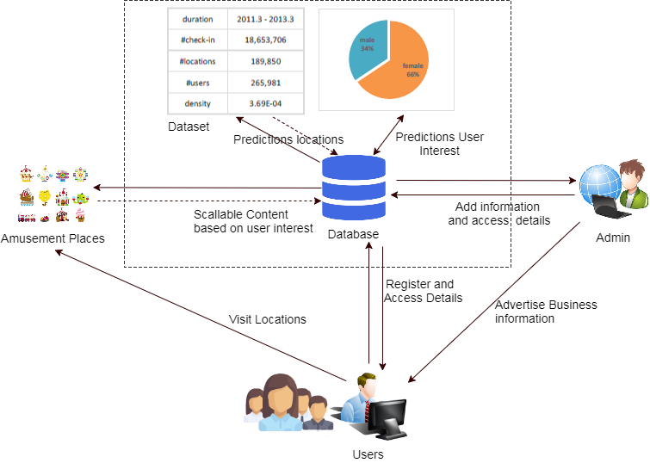

Algorithm:

Bayesian Personalized Ranking based Matrix Factorization (BPRMF), Weighted Approximate-Rank Pairwise (WARP) and Bayesian non-negative matrix factorization algorithm have been exploited for recommending locations, they are still not comparable to weighted matrix factorization

One Class Collaborative Filtering (OCCF) algorithm, This will be validated in our experiments on two other location-based social network datasets. Weighted matrix factorization, being performed on the preference matrix, maps both users and locations into a joint latent space of dimension, where each user and each location is represented by user latent factor and location latent factor respectively, and the preference of a user u for a location is estimated as the inner product between their latent factors, Evaluate recommendation algorithms on visited locations in the held-out set. Presenting each user with the top p candidate locations sorted by their preference prediction, we assess recommendation performance by checking how many of these locations actually appear in each user’s held-out set. Two widely used metrics, recall and precision in prior work are exploited.

System Requirements

H/W System Configuration:-

Processor : Intel (R) Pentium (R)
Speed : 1.1 Ghz
RAM : 2GB
Hard Disk : 57 GB
Key Board : Standard Windows Keyboard
Mouse : Two or Three Button Mouse
Monitor : SVGA

S/W System Configuration

- Operating System : Windows 8/7/95/98/2000/XP
- Application Server : Tomcat5.0/6.X/8.X
- Front End : HTML, Java, Jsp
- Scripts : JavaScript.
- Server side Script : Java Server Pages.
- Database Connectivity : Mysql.
- Java Version : jdk 1.8

CONCLUSIONS

we study and implement that newly develop and well developed cities entertain, restaurant places are recommended to people to visit and entertain, collect feedback about their visiting experience. And also provided business opportunities to the users. We propose an ICCF framework for content-aware collaborative filtering from implicit feedback datasets, and develop coordinate descent for efficient and effective parameter learning. We establish ICCF’s close relationship with graph Laplacian regularized matrix factorization and show that user features actually refine mobility similarity between users. We then apply ICCF for location recommendation on a large-scale LBSN dataset. Our experiment results indicate that ICCF is superior to five competing baselines, including two state-of-the-art location recommendation algorithms and ranking-based factorization machine. By comparing different weighting schemes for negative preference of unvisited locations.

